Name : Muhammad Hassaan Bin Sohail

**Code Report for the Interview Task**

**Code:**

def main():

    str_data = ''

    with open("term-size.exe", "rb") as f:

        bytes_read = f.read()

    for b in bytes_read:

        char = process_byte(b)

        if(char != None):

            str_data = str_data + str(char)

            print (str_data)

def process_byte(b):

    byte = b

    if ((byte > int('0x20',16)) and (byte < int('0x7f',16))):

        final = chr(byte)

        return final

if __name__ == "__main__":

    main()

**Screenshots of terminal:**

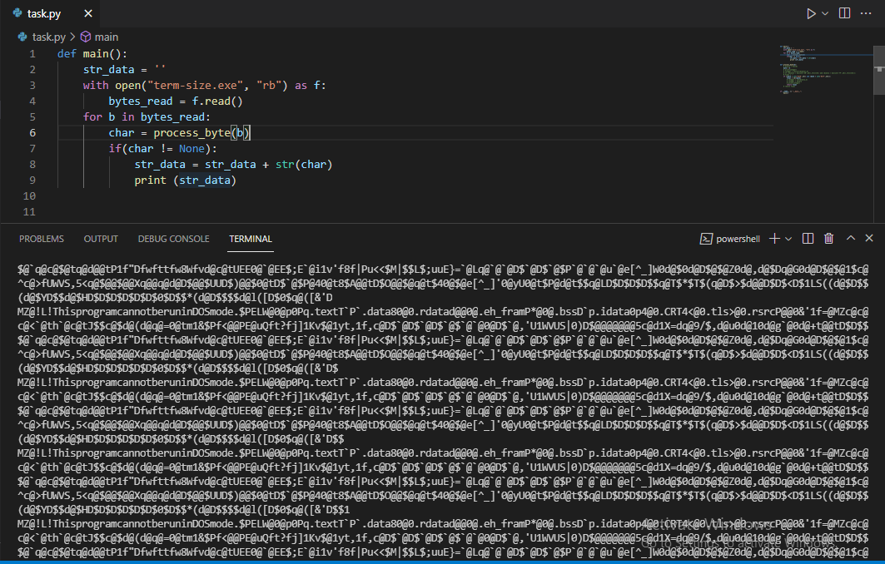

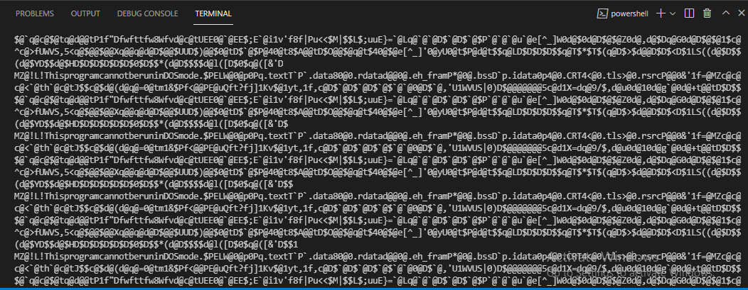

**Code Explanation:**

The code basically takes a random .exe file from the filesystem as input. It opens it with a read only and binary mode. Then in a loop reads each byte sends it to a processing function which checks if it lies between the asciis 0x20 and 0x7F. If it does lie in between converts into the corresponding character which is then returned. The character returned is then concatenated in the string. For values that do not lie in between the range a None is returned which is handled in the main before printing the string.